A picture containing clipart

Description generated with very high confidence

Azure 103 Module 4

Hands On - 4

Azure Certification Training

[**support@intellipaat.com**](mailto:support@intellipaat.com)

**+91-7022374614**

**US: 1-800-216-8930(Toll Free)**

**Azure 103 Module 4 , Hands On – 4**

**Create a VNET to VNET Gateway Connection.**

**Step 1:** Create two resource groups (In separate locations i.e. West India and South India).

**Step 2:** Create two virtual networks in separate regions one in each resource group (Central and South India).

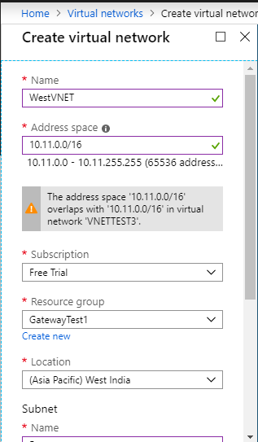

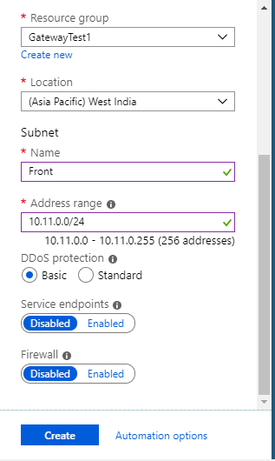

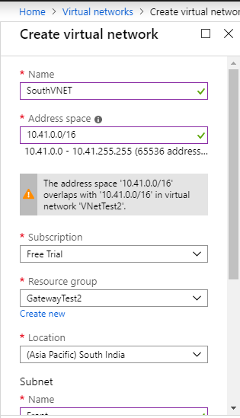

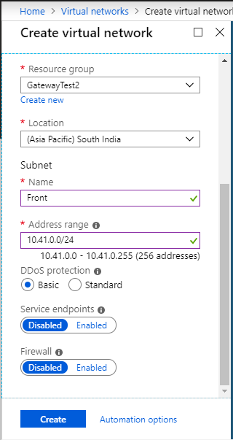

**Step 3:** Open the VNet and go to subnets.

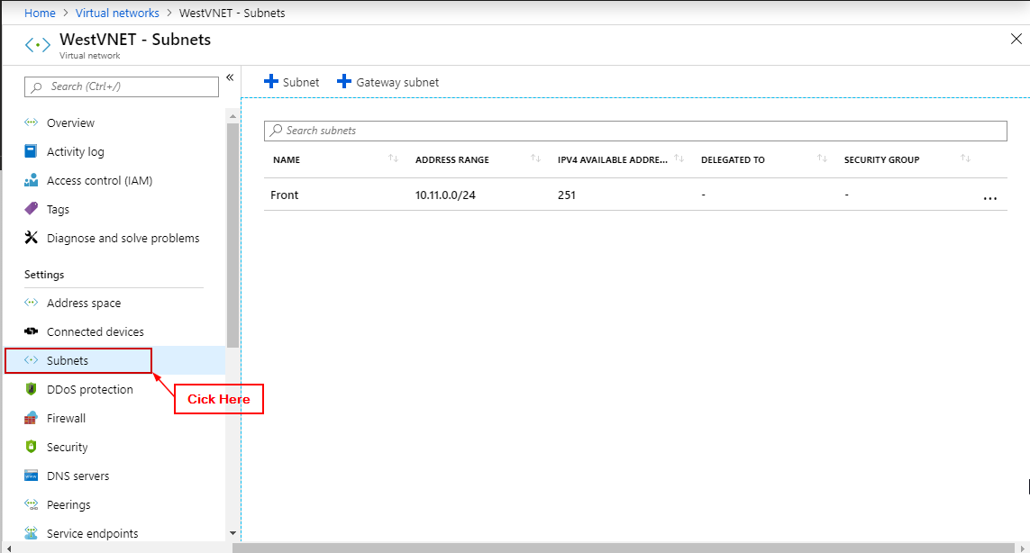

**Step 4:** Click on + Gateway subnet.

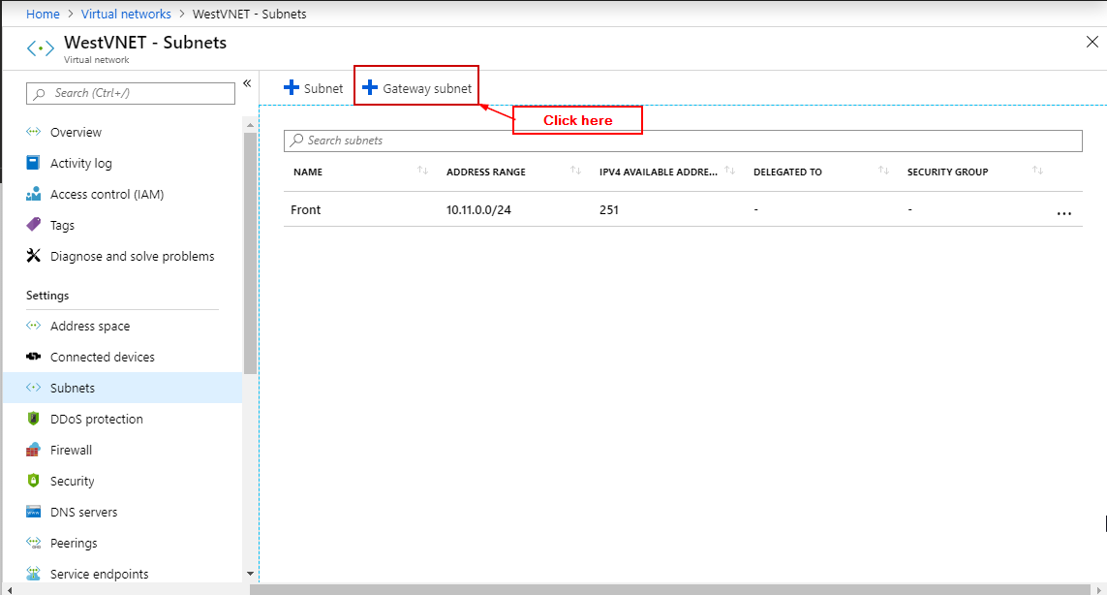

**Step 5:** Enter details and click on OK (Do this for both VNets).

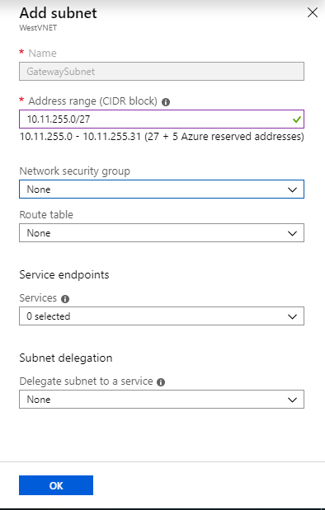

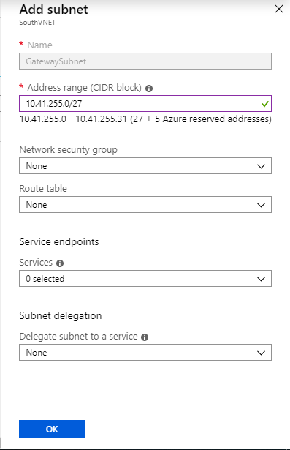

**Step 6:** In Azure portal search for Virtual Network Gateways and click on it.

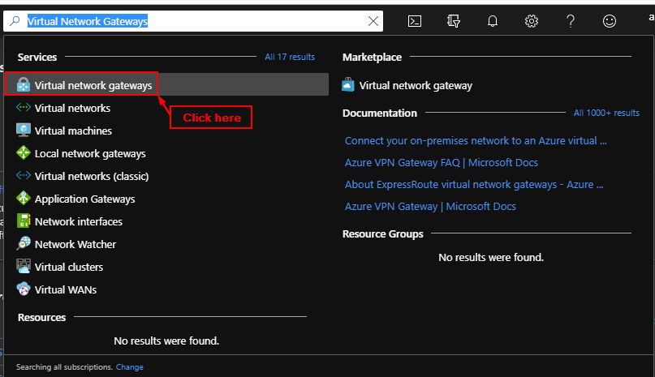

**Step 7:** Click on + Add and Enter information and click create. (Create two Gateways one with each Virtual Network selected that we created earlier).

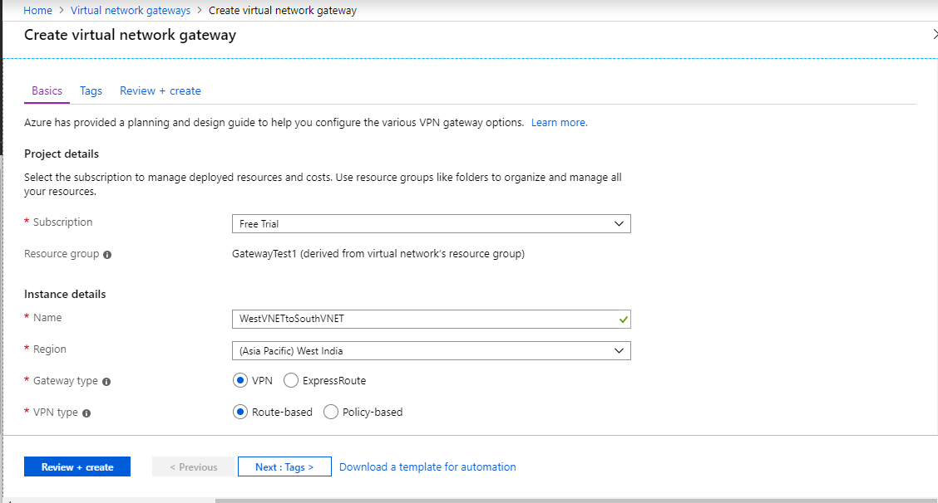

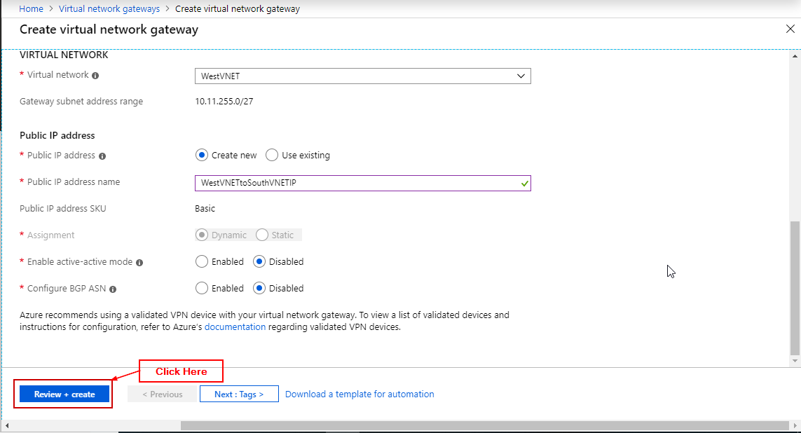

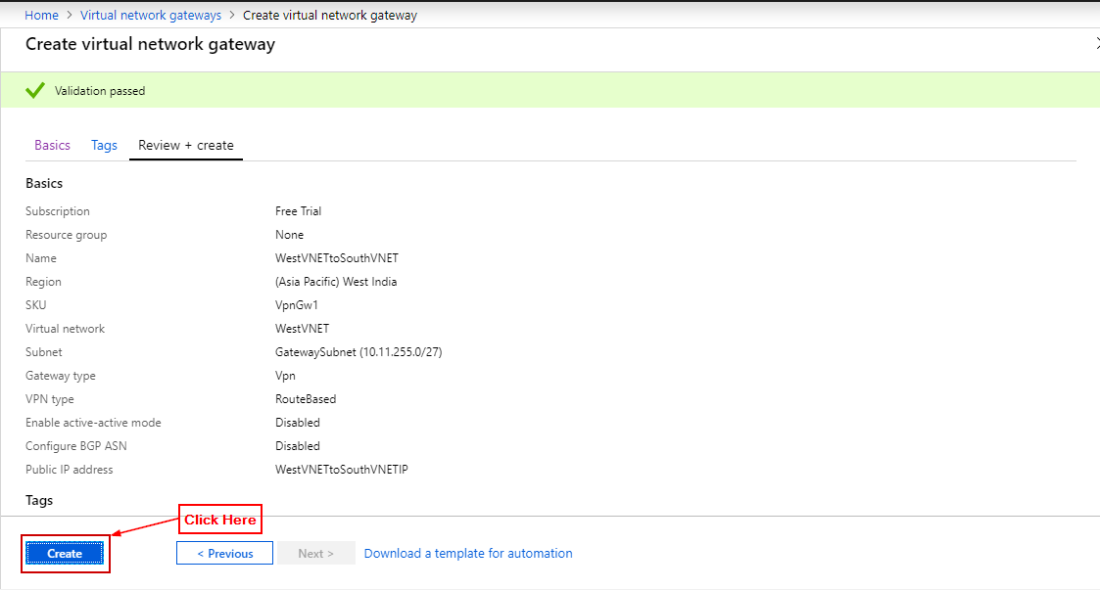

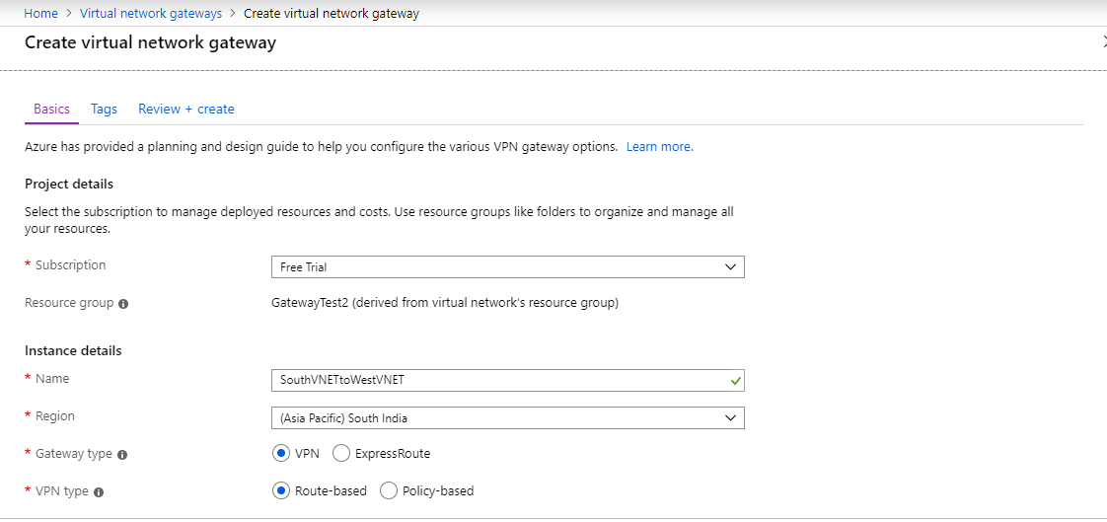

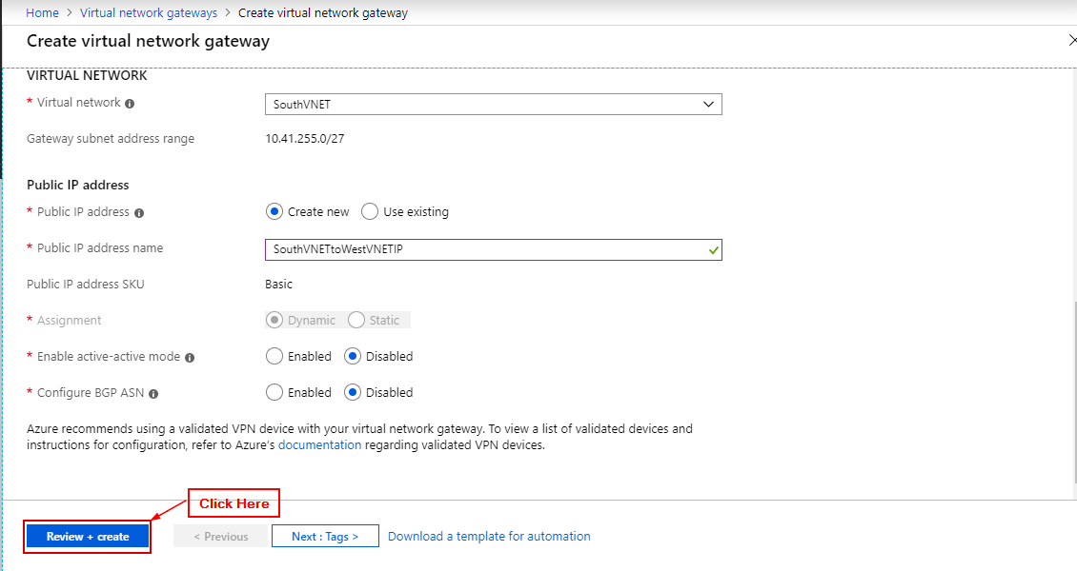

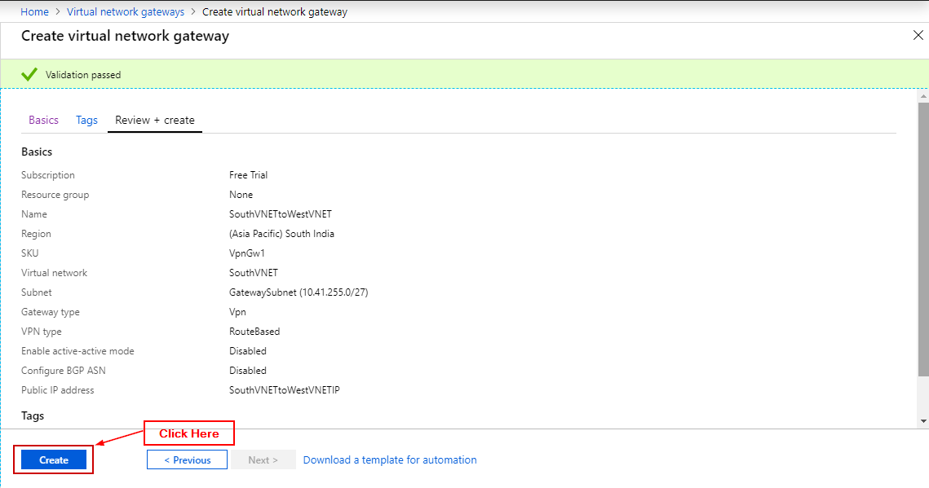

**Step 9:** Open a virtual network click on connections.

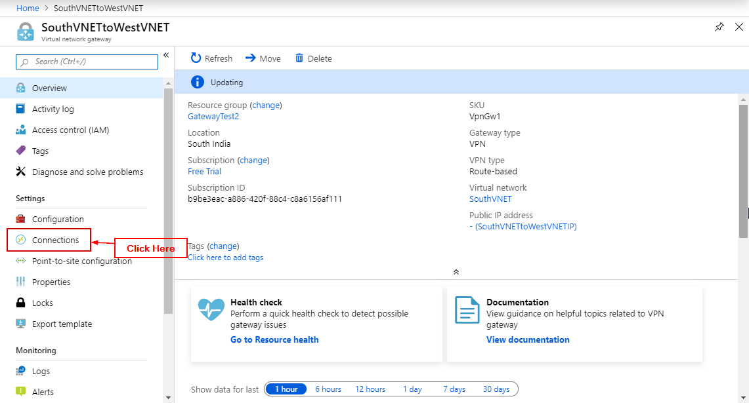

**Step 10:** Click on ‘+ Add’ and fill in details.

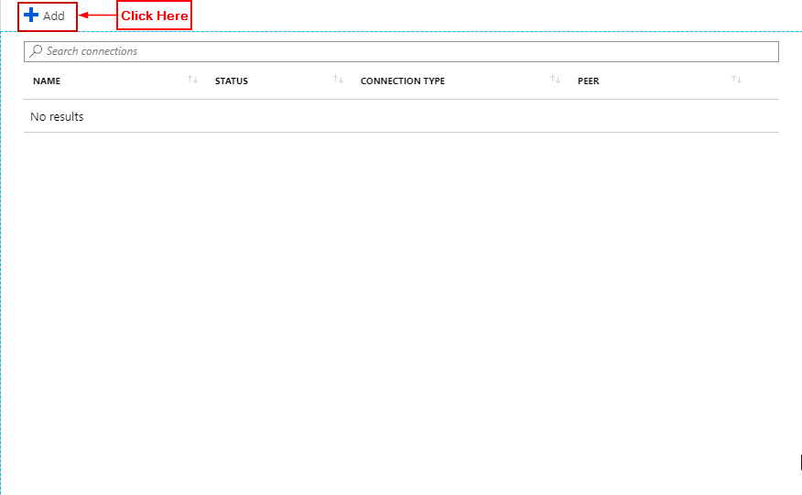

**Step 11:** In the second virtual network gateway select the other virtual network you created that is not selected in the first virtual network gateway field. (Make sure when creating your gateways both your gateways have the same shared key). Click on Ok.

